Date: October 15, 2024
Time: 11:00 am – 12:00 pm (PST)
Location: Microsoft Teams (Virtual Meeting)
Title: Pre-Submittal Meeting for RFQ #SCL-767056021; On-Call Dam Safety Consulting Services
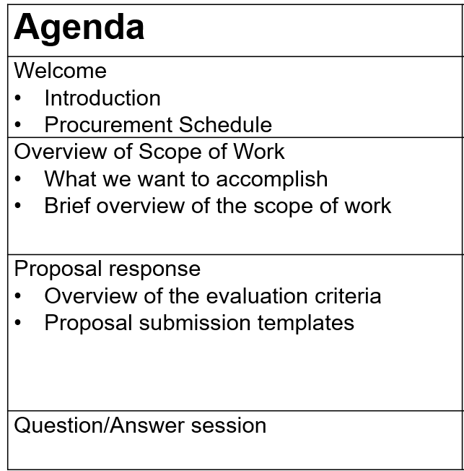
For those in attendance, please confirm your attendance by sending an email to Ned.Lichty@seattle.gov with the following information:
- Your Name & Title:
- Your Company:
- Note if your company will be a Prime Consultant if awarded contract, or a Subconsultant?
Link to join meeting is below
Microsoft Teams Need help?
Join the meeting now
Meeting ID: 270 784 241 797
Passcode: kiLYpm

Dial in by phone
+1 206-686-8357,,889295762# United States, Seattle
Find a local number
Phone conference ID: 889 295 762#
Join on a video conferencing device
Tenant key: seattle@m.webex.com
Video ID: 113 019 522 2
More info
For organizers: Meeting options | Reset dial-in PIN
________________________________________________________________________________

