Address:
Nearest Address
3150 N Belcher Rd, Palm Harbor
(Sutherland Elementary School)
Site is just South of address

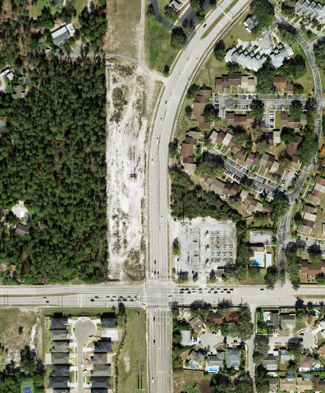
Project Area Park here

