Date: Monday, March 17, 2025
Time: 12:00 pm – 1:00 pm (PST)
Location: Microsoft Teams (Virtual Meeting)
Title: Pre-Submittal Meeting: RFQ #SCL-767059905; Fish Passage and Stream Restoration Design in the Boundary Tributaries.
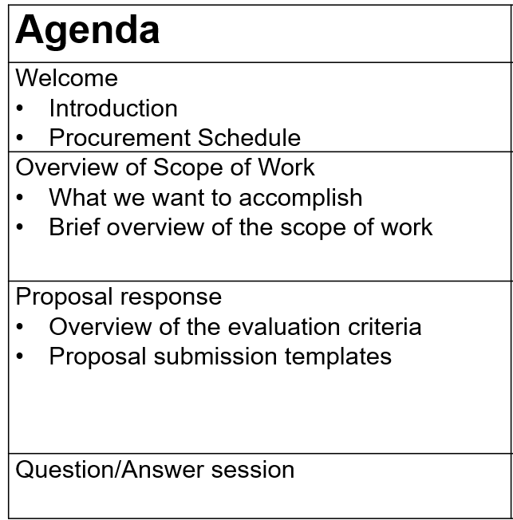
For those in attendance, please confirm your attendance by sending an email to Ned.Lichty@seattle.gov with the following information:
- Your Name & Title:
- Your Company:
- Note if your company will be a Prime Consultant if awarded contract, or a Subconsultant?
Link to join meeting is below
Microsoft Teams Need help?
Join the meeting now
Meeting ID: 262 633 996 360
Passcode: gb6BL7bi
Dial in by phone
+1 206-686-8357,,736811936# United States, Seattle
Find a local number
Phone conference ID: 736 811 936#
Join on a video conferencing device
Tenant key: seattle@m.webex.com
Video ID: 119 886 025 3
More info
For organizers: Meeting options | Reset dial-in PIN

