5 Airpark Road, West Lebanon, New Hampshire 03784
PH: (603) 298-8878 Fax: (603) 298-5845
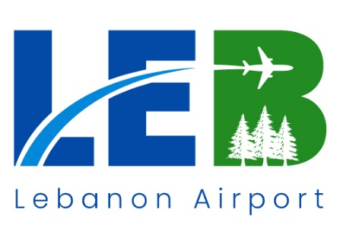
www.FlyLEB.com

Project: 2025-RFx-001
Lebanon Municipal Airport - Pavement Crack Sealing

Date: 14 February 2025
Time: 3:00PM
Location Airport Conference Room
Airport Terminal Building, 2nd floor

Agenda
- Unseal and open bids for the project in OpenGov.

